
Editors Comments
Where is this year going? I must be getting old, as time just seems to fly by, at last the evenings are getting lighter, but is it just me or is it still very cold? Anyway spring is here, this is my favourite season, lambs, spring flowers, young birds and animals and everything fresh and new.

As you will see from this issue, people have been very busy fundraising in all sorts of ways. There have been charity concerts, supermarket collections, counter tins in shops, pubs and sporting venues, donations from dance shows and the Inner Wheel after I spoke at one of their meetings. What I am trying to show is that there are many different ways in which we can help to raise money. If we all try to do our bit, then you will be surprised what a difference we can make. You may have read recently that we are trying to buy a new minibus for our group, so if you have any idea to raise money, no matter how small, every little helps. Frank has several supermarket collections lined up over the next few months, please contact him if you (or someone you know) can spare an hour or two, as at the moment it always seems to be the same few people doing this.

Have you been to our new drop-in at St Patrick’s Church on Beaumont Leys Lane? We still meet on Tuesday 11.00am – 2.00pm. It would be great to see you there.
Jane

The Tudor Choir

Many thanks to The Tudor Choir who on Saturday 3 December sang, Faure Requiem Monteverdi Beatus Vir, at St John the Baptist Church Clarendon Park. The acoustics were brilliant and church rang with their joyous voices. Superb soloists included the young Kirsty Rae, who I’m sure we will here more of. The choir obviously enjoy singing and this shows in their performance that raised £400.00 for our branch. Very uplifted Brad (Sue’s husband) and I ventured onto Queens Road for a swift pint before trudging home in the ever worsening weather. The things we do for the MS Society!

The same choir performed Broadway to Hollywood. On Saturday 25th February 2006, a miserable night, Pat, Pete and I set of to find the Fraser Noble Building on London Road. This building has a very small austere front squeezed between a church and a pub. Access is easy via a good ramp. It was like entering an old school with painted corridors and staircases off, but when you went into the concert hall ‘Wow’. The beautiful ceiling was decorated in the Wedgewood style of light blue and white, it was very impressive. The choir filed in and blasted off with Cole Porter’s ‘Another opening of another show’ and never looked back. The Brian Humpherson Trio, apart from backing, did a couple of sets and were superb, especially the leaders son on drums who played a great solo. (never buy your offspring a drumset, I wonder where he practices). The ‘Razzle Dazzle’ number by three ladies was very cheekily acted and sung. A good night rounded off with a glass of wine and nibbles. A great choir giving a great performance raising £500.00, our grateful thanks go to them.


The collection at the Co-op at Whetstone on Saturday 18th March raised £508.00, well done to everyone who gave their time on such a very cold day.

Talking of collections, thank you to everyone who collected over three days outside Morrisons. Despite having difficulty finding volunteers to shake buckets, my thanks go to the usual crew who collected the grand total of £1,204.00. Frank

Many thanks to The Navigation Inn in Barrow on Soar, their MS counter tin contained the grand sum of £64.00.


Charnwood School of Dance and Drama in Loughborough (the school where my daughter dances) held four dance shows during February. They very kindly gave the raffle proceeds to our branch. This came to the fantastic total of £460.00 which they rounded up to £500.00. My thanks go to Barbara, Barrie, Helen, Mark and Rachel Stephenson for this large donation that will go towards the purchase of a mini-bus.
Jane

Kibworth Shooting Ground

Frank collected a counter tin from the Kibworth Shooting Ground which contained the magnificent sum of £80.00. Thank you to all concerned.

Soar Valley Inner Wheel

Jane gave a half hour talk to the ladies of the Soar Valley Inner Wheel in March. This resulted in a donation of £100.00 to our branch. Many thanks to them.
Ulverscroft Grange 23 March 2006

Ten of us spent a very enjoyable day at Ulverscroft Grange. After coffee and biscuits on arrival, we were treated to roast lamb, potatoes, peas, carrots, cauliflower and cabbage, followed by a very alcoholic tasting sherry trifle. The weather, company and views were fantastic as was the home made cake served with tea in the afternoon! If you didn’t go, you missed out!

Midsummer Players Concert 28 and 29 April

About ten of us from the drop-in went along to this fantastic show. The production entitled ‘All that Jazz’ was performed at Kirby Muxloe Village Hall, which was an ideal venue for us. Good car park, access and disabled toilet. The singers entertained us with many well-known songs that we could sing-a-long to. A very accomplished, professional performance by everyone involved. If you didn’t manage to go, you missed a wonderful evening. At this stage we do not have a figure raised but all proceeds are for the minibus fund.
Forthcoming trips and events

Tudor choir 24 June 2006

The Tudor choir are performing their last concert for us on Saturday 24 June 2006, at The Guildhall, Guildhall Lane. 7pm for 7.30pm Mosaic a summer evening of early music. Tickets for this concert include a glass of wine and are available on the door or in advance from Judy Dodd, 54 Letchworth Road, Leicester LE3 6FG

Price: Adults £9.00, Concessions £7.50, Students £4.00. Please enclose a stamped addressed envelope.

Peter Le Marchant boat trip 30 August

Once again our popular boat trip has been arranged, this year hopefully travelling in the other direction towards Kegworth. All being well we will be stopping for lunch at The Plough at Normanton which is disabled friendly. You can eat either at The Plough or take a picnic with you. Book early are spaces are strictly limited to 25.

COLLECTIONS
Page 3

We are looking for volunteers to “shake a can” outside the Sainsburys supermarket in Grove Park (near Fosse Park) on Monday, Tuesday and Wednesday, 17, 18 and 19 July 2006.

On Saturday and Sunday 21 and 22 October we need help at Sainsburys in Oadby. Lastly we have another collection outside Asda at Oadby on Friday and Saturday 1 and 2 December.
You can offer to collect for a single one-hour slot, or more – whatever you feel able to do. It is all in a very good cause, and our supermarket collections are a very important source of revenue for branch funds.

So , please don’t wait to be asked – pick up the phone now and ring Frank on 0116 2606467

Date for your Diary


Evening Concert on the Lawn at Ulverscroft Manor

Featuring Music from the 1940’s and 1960’s
Saturday 17th June, 2006
Bring your own picnic table and chairs, relax and enjoy the evening.

Gates open at 4.30pm
The concert begins at 7pm
Advance Tickets £6.00
£7.50 on the day


Cards for any occasion

How many times have you looked for that special card, and couldn’t find quite what you wanted. Well now help is at hand. I make cards to order with names if required. Just give me about four weeks notice in case I am not well.

All cards only £1.50

Michelle Gutteridge
Telephone 01455 840273
email michelle.gutteridge@hotmail.co.uk

p.s. I am always on the look out for shiny paper, sequins or anything that could be used to help me make these cards. Just bring anything suitable along to the Tuesday drop-in. Thank you.
Annual General Meeting

The A G M was held on Tuesday 25 April 2006 at our new drop-in venue at St Patricks Parish Centre, on Beaumont Leys Lane. There was a healthy turn-out of members. The committee were unanimously re-elected and is as follows:

President Steve Johnston
Chairman Alan Stevens
Secretary Peter Sibson
Welfare assistant Peter Sibson
Treasurer Jo Stevens
Fundraising Frank Wheatcroft
Membership Sue Bradbury
Newsletter editor Jane Tindle
Shop Management Diane Brown
Committee Marlene Kuhn-Sibson
Committee Pete Bostock
Committee Ann Jones
Committee Elaine Blakeman
Committee Geoff Wakeling

The date of next years AGM will be set nearer the time.

TUESDAY
Drop In sessions

EVERY TUESDAY 11am till 2pm

Easy access and car parking
Light refreshments
and disabled toilet facilities available

A Voluntary Donation is asked from those
receiving Therapies to help offset the
Practitioners Fees

Reflexology, chiropody, manicures and many
other treatments available. See drop-in diary
for dates.

Venue:- St Patricks Church
Beaumont Leys Lane
Leicester

Stem Cell Treatment

The MS Society continues to receive regular queries about the feasibility of stem cell treatments for MS, following recent media reports. Although stem cell science is advancing rapidly, there is no scientific evidence as yet to support a stem cell treatment in humans to repair MS damage, and some types of stem cell treatment may be very hazardous. Publicity for the treatment has raised people’s hopes, but the MS Society advises people that no scientific data has verified the treatment on sale. Stem cells are 'unspecialised' cells that have the potential to turn into many different cell types because of their early stage of development. In the future stem cells could possibly be used to replace damaged tissues like nerves in the brain and spinal cord in people with MS.

Stem cells are found in both embryos and adults. Whereas embryo stem cells can generate any cell type, those from adults are more restricted. There was great excitement last year when Professor Hwang Woo-suk, from Korea, claimed his research team had developed a new technique to produce embryonic stem cells genetically identical to the adult they were to be transplanted into.

However, an investigation committee has now shown that Professor Hwang Woo-suk's results were fabricated and that the stem cells were not made using the technique he claims. He has since resigned his position.

There have also been many articles in the press recently about people with MS visiting a clinic in the Netherlands and receiving treatment. It is an area which continues to attract a great deal of publicity.

Stem cells still have great potential for use as a therapy in MS and research is continuing. The MS Society is currently funding Professor Neil Scolding at Bristol to determine the potential of adult derived bone marrow stem cells for nervous system repair in MS. Professor Scolding will be giving a talk at the MS Convention, Manchester in April.

For more information on stem cells:
There is more information on MS and stem cells on our website www.msociety.org.uk including our position statement.

The Medical Research Council website at www.mrc.ac.uk and the Institute of Stem Cell research pages at www.iscr.ed.ac.uk also carry useful information.

The research team and the helpline will have the most update information should you see anything in the news which concerns you. Call 020 8438 0770 or 0808 800 8000.
We Must Stop This Immediately!
Have you noticed that Stairs are getting steeper , Groceries are heavier. And, everything is farther away. Yesterday I walked to the corner and I was dumbfounded to discover how long our street had become!
And, you know, people are less considerate now, especially the young ones. They speak in whispers all the time! If you ask them to speak up they just keep repeating themselves, endlessly mouthing the same silent message until they're red in the face! What do they think I am, a lip reader?
I also think they are much younger than I was at the same age. On the other hand, people my own age are so much older than I am. I ran into an old friend the other day and he has aged so much that he didn't even recognize me
I got to thinking about the poor guy while I was combing my hair this morning, and in doing so, I glanced at my own refection..........Well, REALLY NOW- even mirrors are not made the way they used to be!
Another thing, everyone drives so fast these days! You're risking life and limb if you happen to pull onto
the freeway in front of them. All I can say is, their brakes must wear out awfully fast, the way I see them screech and swerve in my rear view mirror.
The people who make bathroom scales are pulling the same prank, but in reverse. Do they think I actually "believe" the number I see on that dial? HA! I would never let myself weigh that much! Just who do these people think they're fooling?
I'd like to call up someone in authority to report what's going on -- but the telephone company is in on the conspiracy too: they've printed the phone books in such small type that no one could ever find a number in there!
All I can do is pass along this warning: We are under attack! Unless something drastic happens, pretty soon everyone will have to suffer these awful indignities.
PLEASE PASS THIS ON TO EVERYONE YOU KNOW AS SOON AS POSSIBLE SO WE CAN GET THIS CONSPIRACY STOPPED!
PS: I am sending this to you in a larger font size, because something has caused my computer's fonts to be smaller than they once were too!!

ADAPTED VEHICLE AND DISABLED EQUIPMENT HIRE IN SPAIN

If you would like to go abroad to Southern Spain but are restricted because of special equipment needs, then you may be interested in the following:-

A member of Worthing and District Branch has recently been to Spain (near Malaga) with his wife and used the services of two businesses to provide for their disability needs.

Steve Hughes hires out disabled friendly vehicles, which will take a seated wheelchair passenger and carry four passengers (including the driver). The person with MS found Steve to be very kind and considerate and he can be contacted on his e-mail address freeweelin01@msn.com.

If you need equipment such as a mobile hoist, air mattress, commode etc then brothers John and James will hire these things out and bring them to your accommodation.

Their UK phone number is 08456442892 or contact them direct in Spain on (00 34 from UK)) 952 447764. For further details have a look at their website which is www.mobilityabroad.com.
The long awaited answers are below !
What is correct name given to the dot on top of the letter "i"? | Tittle
What does the word Cenotaph mean? | Empty tomb
Why can't a man living in York be buried west of the Trent? | Because he’s not dead yet
What was Marilyn Monroe's first married surname? | Dougherty
By what name is Barbara Millicent Roberts better known? | Barbie
In the board game monopoly, what colour is Bond Street? | Green
The official name of `the Old Bailey`? | The Central Criminal Court
The order of the British Empire, what does the letter `C` stand for in CBE? | Commander
The most common accident in UK Struck By Static Object, Struck By Moving Object or Tripping Over? | Tripping over
St. Edmund is buried in? | Bury St Edmund
THREE NEW ESSENTIALS LAUNCHED

The MS Society's excellent Essentials series continues to grow with three new publications: Mood, depression and emotions; Sex, intimacy and relationships; and Diet and nutrition.

The physical symptoms of MS are well known, but less well recognised are the mood, emotional and behavioural symptoms which can cause great distress. Sometimes these often easily treatable symptoms are overlooked or even dismissed. Mood, depression and emotions identifies and explains these difficult symptoms and shows how medication, therapies such as counselling and psychotherapy, and self-help techniques can help make it easier to cope. It describes the difference between mood changes caused directly by MS and others which are not. Even the less common symptoms ranging from euphoria to lack of insight or initiative are also described.

Many people with MS experience physical sexual difficulties brought about by the damage the condition has caused to their central nervous system. Symptoms like fatigue and spasm and psychological factors like low self-esteem and mood can also impact on how people with MS express their sexuality.
The new booklet, Sex, intimacy and relationships describes different types of male and female sexual

dysfunction and the treatments and techniques which can help to cope with them. It looks at easing the impact of specific symptoms, ranging from spasticity and pain to bladder, bowel and cognitive problems.

Diet and nutrition looks at the importance of eating nutritionally balanced meals to anyone with a long-term, unpredictable condition like MS. It describes what makes up a healthy diet and makes suggestions for what to include and avoid, including changes which may help with managing specific symptoms. There is practical advice on preparing food and managing weight, and on caring for the dietary needs of people more severely affected by MS. The booklet also looks at the possible benefits of essential fatty acids, vitamins and minerals.

Order a copy of any of these titles or any other MS Society publication by writing to MS Society Publications, PO Box 142, Bedford, MK42 0FA. Please give your name and address details clearly, including postcode. Or download a copy from www.mssociety.org.uk.
WHATS ON
M S TUESDAY DROP-IN
MONTHY PROGRAMME

WEEK | EVENTS
 | 1 | 2 | 3 | 4
1  1st  Tue |  | 11.45 – 12.30  VAL  Relaxation | 13.00 - 13.30  Monthly  QUIZ £1.00  Cash Prize  50% | 13.30 – 14.00  RAFFLE  DRAW
2  2nd  Tue | 11.00 – 14.00  RAAKHEE  Alternative  THERAPIES |  | 11.45 - 12.30  VAL  Relaxation | 13.30 – 14.00  RAFFLE  DRAW
3  3rd  Tue | 11.00 – 14.00  ALISON  M.S. NURSE  Surgery | 11.45 - 12.30  VAL  Relaxation | 12.45 – 13.30  BINGO  £1.00  CASH PRIZE  50% | 13.30 – 14.00  RAFFLE  DRAW
4  4th  Tue | 11.30 – 14.00  New Age Curling | 11.45 - 12.30  VAL  Relaxation |  | 13.30 – 14.00  RAFFLE  DRAW
5  5th  Tue  30th May 06  29th Aug 06  31st Oct 06  30th Jan 07  29th May 07  31st Jul 07  30th Oct 07 |  |  |  | 13.30 – 14.00  RAFFLE  DRAW

Just to explain our ‘new look’ calendar. It has been decided that we will run a rolling four weekly programme of events at the drop-in. So for example week one is the first Tuesday of the month, you can see that at 11.45pm, Val is holding her relaxation class, followed by a monthly quiz with cash prize at 1.00 pm, and lastly at 1.30pm, the raffle will be drawn.

On the second Tuesday of the month, at 11.00am Raakhee is in attendance, Val’s class is at 11.45am and again the raffle is at 1.30pm.

Some months there are five weeks, just to make it difficult! These are listed at the bottom of the programme and we may have speakers on these dates.

I hope this has explained it clearly to you, and that everyone will now know, what’s on when!!

Multiple Sclerosis and sleep


A common symptom of MS is general fatigue and this report discusses the relevance of underlying sleep disorders. Sleep disorders, as opposed to general tiredness, should be correctly diagnosed since the two complaints require different treatment strategies. For example, clinical studies have shown that the drug Modafinil used for excessive sleepiness has no effect on fatigue.

Fifty percent of MS patients report that the quality of their sleep is inadequate. In order to determine a correct diagnosis it is important to recognise that a patient may use the term “fatigue” to describe sleepiness. A patient is initially required to fill out a sleep diary and give a symptom history to decide if there is a primary sleep disorder. It is possible that medications the patient is taking may affect sleep patterns.

Electrophysiological tests looking at electrical activity of the brain can be used to determine the quality of night time sleep and various day time tests are used to look at sleep drive though out the day. Similarities between the sleep disorder narcolepsy and MS have been reported, indicating that these patients have a predisposition to excessive sleepiness. Napping and sleeping throughout the day can affect the quality of night time sleep and these features need to be determined.

Patients with MS can also suffer sleeping disorders to the same extent as the general population, such as insomnia or sleep apnoea where breathing temporarily stops for example. Given that over 30% of the general population suffer from primary insomnia which is not related to any psychiatric, medical or identifiable reason, it is probable that some MS patients have the same issues. However, MS patients may have additional sleep disruption problems such as leg-jerking movements which affect their ability to sleep as seen in 36% of patients.

Fatigue issues can be reduced by avoiding excessive heat, modifying time management of daily activities, and identifying whether depression is an underlying factor. Certain drug strategies such as Amantadine can be used. However, it is important to obtain a correct diagnosis whether it is a sleep or fatigue problem.

This report was published in ACNR, volume 5, 2005

Don’t worry about what people think, they don’t do it very often.
Did you know ?
Some useless facts for you to remember!

Coca-Cola was originally green.

The most common name in the world is Mohammed.

The name of every continent ends with the same letter that they start with.

The strongest muscle in the body is the tongue.

TYPEWRITER is the longest word that can be made using the letters on only one row of the keyboard.

Women blink nearly twice as much as men!

You can't kill yourself by holding your breath.

It is impossible to lick your elbow.

The "sixth sick sheik's sixth sheep's sick" is said to be the toughest tongue twister in the English language.

If you sneeze too hard, you can fracture a rib. If you try to suppress a sneeze, you can rupture a blood vessel in your head or neck and die.

If a statue of a person in the park on a horse has both front legs in the air, the person died in battle. If the horse has one front leg in the air, the person died as a result of wounds received in battle. If the horse has all four legs on the ground, the person died of natural causes.

A snail can sleep for three years.

All polar bears are left handed.

American Airlines saved $40,000 in 1987 by eliminating one olive from each salad served in first-class.

Butterflies taste with their feet.

Elephants are the only animals that can't jump.

In the last 4000 years, no new animals have been domesticated.

Shakespeare invented the word 'assassination' and 'bump'.

Stewardesses is the longest word typed with only the left hand.

The electric chair was invented by a dentist.

The human heart creates enough pressure when it pumps out the body to squirt blood 30 feet.

Rats multiply so quickly that in 18 months, two rats could have over one million descendants.

Most lipstick contains fish scales.

Like fingerprints, everyone's tongue print is different

And finally 99% of people who read this will try to lick their elbow!


Sportability

Sportability is a charity that enables disabled people to take part in many different sporting activities. We are very fortunate to have this facility right here in the Midlands.

There is a programme of events arranged throughout the year, kicking off with a first for Sportability, Snowmobiling! I went along to Tamworth Snowdome to try out this experience first hand. I liken it to quad-biking on ice.

The dates arranged so far are:-
3 May Snowmobiling at Tamworth
14 May Canoeing at Quorn Hall
20 May Quad biking at Leicester Outdoor Pursuits
15 June Falconry at Twin Lakes, Melton

If you are interested in participating in these or any future events, contact Jane on 01509 414201 or email jane@tindle01.fsnet.co.uk.
Sportability website for further information www.sportability.org

The VATman cometh

We routinely are asked questions on VAT. This article is to help clarify what goods and services are VAT free to people with MS.

People with MS can avoid paying VAT on the following goods and services, provided they are supplied to the PwMS for their personal use:
· Adapted motor vehicles to fit a wheelchair– providing the adaptation is done when the vehicle is purchased and not separately.
· The hire of an adapted motor vehicle
· The purchase of aids specifically designed to help people with disabilities including medical and surgical appliances.
· Adjustable beds, chair lifts, hoists, lifts and sanitary devices
· Emergency alarm call systems
· The purchase of a boat
· Repair and maintenance of the above
· Parts and accessories designed solely for use in any of the above.
· The installation and adaptation of goods mentioned above
· Construction of a ramp or the widening of a doorway at a PwMS’s private residence
· Extending and adapting a bathroom, washroom or lavatory at a PwMS’s private residence.
The builder will need to purchase any new bath/shower/washroom facilities to avoid paying VAT on these items.
In all cases you will need to provide the supplier with a certificate and copies of these are available from the Treasurer.
If a person has applied for a support grant for any of the above you should ensure that they are not paying VAT on the item.

BEAUMONT LEYS SHOPPING CENTRE

Today, I have been shopping to Beaumont Leys, exciting huh?! Well I had such a stress free enjoyable time that it has prompted me to write about it. As most people who attend the drop-in probably already know, this really is a disabled-friendly place, so I thought I would let everyone else in on this info!

The choice of shops is good, Tesco’s, Boots, W H Smith, Matalan, Next, Wilkinsons, McDonalds, card shops, shoe shops, and clothes shops as well as a Post Office, travel agents etc etc. I have found that all the shops are accessible (ie no steps) some have heavy doors but the staff and public are extremely helpful. I also went to the café opposite Tesco’s, where there is a wheelchair/scooter friendly toilet. I have also discovered that the staff in Tesco’s are only too willing to help, either carrying a basket or pushing a shopping trolley around the store for me, and packing my shopping at the till.

So, if you would like to sample a little bit of retail therapy, why not go to Beaumont Leys.

Jane

The Quiz
The Quiz returns………
What colour flower does Winter Jasmine have?
Surfina is a trailing variety of which Summer annual?
Digitalis is the botanical name for which biennial plant?
What is the common name for the plant Dianthus?
Is oil added to a 2 stoke or 4 stroke engine in mowers?
What is the common name for the plant Antirrhinum?
Name 4 herbs starting with the
letter 'C'
Dolly, Jewel, Warpath and Little Gem are all varieties of which summer veg?
Can you eat Nasturtiums in salad?
Entries to Jane (address on the back page)
by 31 May 06.
Name …………………………………………….
Address…………………………………………..
Here I another of my favourite poems, come on everyone send me yours to share with others.

Accept Me

I am I
Do not change me
Condemn me
Nor put me down
Accept me for what I am
No… you need not agree with me
But accept me
For I am total in being
I have my faults
I have my guilts

But that is who I am
Perfect I will never be
Allow me to be uninhibited
Do not pressure me into feeling
What I do not feel
Accept me when I am flying high
As I have accepted you when
You were flying high
Do not put me down … nor make
Me feel unhappy about me
I am I
And I like being what I am
Me

Larry S Chengges

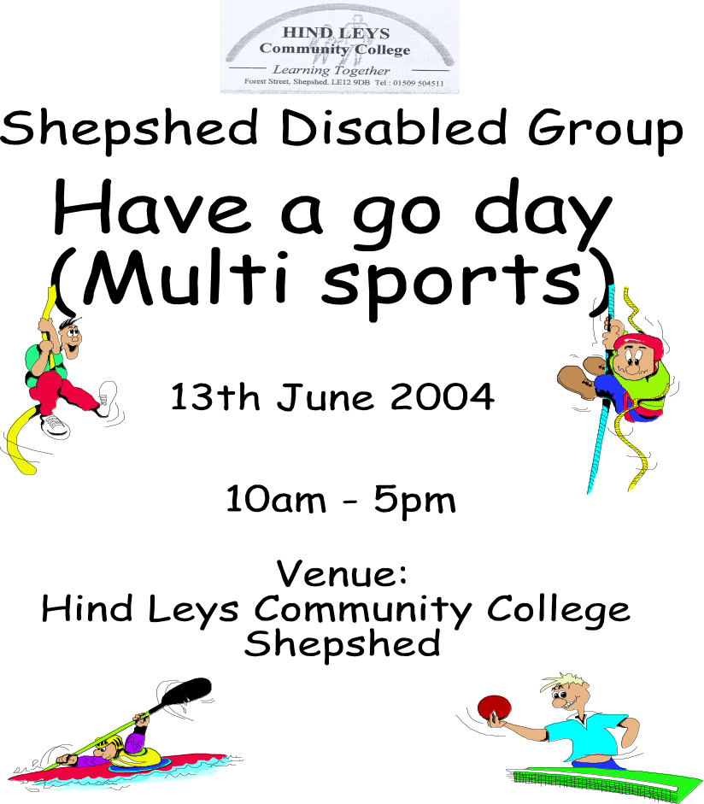

11th June 2006

Please sign in at reception on arrival
Snack bar serving food and drink will be open all day
Licensed bar 12.00 – 3pm, BBQ and picnic area
Swimming kit is required to take part in canoeing, swimming or sub aqua. Trousers are required for horse riding.

Contact Nina & John Walker (01509) 506392

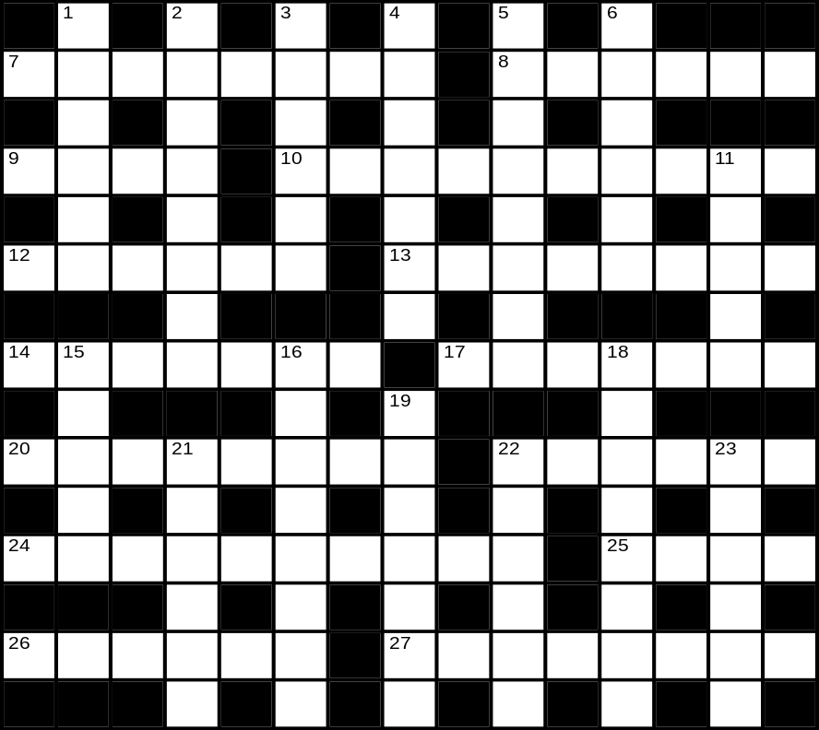
Across
7 Can silk be so ruined as to be like stone needles with honourable beginnings? (8)
8 Fearful a loss may create ripple effect. (6)
9 Land mass is discovered in a Creole. (4)
10 United Nations abandon Kelly for sort of bread. (10)
12 Rhesus type will show you where to sit. (6)
13 Rose without frills. (8)
14 In curt manner I take British Rail to be sly about the weekend. (7)
17 Salesman produces eggs to review the action. (7)
20 A broad view, as seen on TV. (8)
22 Showing teeth-marks? To rub it tentatively is more than enough. (6)
24 Floaters? Nearly flyers!. (10)
25 Mantra I like to hide a line in. (4)
26 To do so could make us pure. (6)
27 Extra is the sum total. (8)
Down
1 Grab a custard tart only to discover it has an old calculator in it. (6)
2 'ZZZZ' may be all they say, but they do help keep the trains on track. (8)
3 Is Sue so silent mostly? Not when there are important subjects to divulge. (6)
4 Resoluteness loses its tenor, becoming fit for nothing. (7)
5 Beg a rake to reform - only leads to rupture. (8)
6 Upset from start to finish. (6)
11 Hear lying is partly at the crack of dawn. (5)
15 Prepared for willing and able accompaniment. (5)
16 Off the leash? Eco-friendly, in fact. (4-4)
18 'Lo-calorie' tariff means you can read and write. (8)
19 Money taken from per capita loss. (7)
21 Beastly female is in gross muddle around the end of June. (6)
22 Next to some of the jibes I detest . (6)
23 Hack chief tried to arrange outside the ring. (6)
Here are some genuine adverts from newspapers

with I hope some genuine errors!

ELECTRIC WHEELCHAIR Sungift, 250 mph, class 2, with battery charger, almost new, £450.

LARGE NUN with head dress excellent condition £40.

FISH BOWL Plastic with wee, bridge, ½ box holiday food + water conditioner

ANTISOCIAL BEHAVIOUR CO-ORDINATOR. You will already be established as a specialist in areas of antisocial behaviour, including drug related issues.

50 YEAR old hens, brown egg layers, £5.



Go on – drop me a line

Please send any articles, jokes, poems for the next issue by 16 June 2006

Write to: email:

Jane Tindle jane@tindle01.fsnet.co.uk
45 Melton Road
Barrow on Soar telephone:
Loughborough
Leics 01509 414201
LE12 8NS

